Research proposal. Susan Askew

Title: Fictioning, with installation and/or performance,(radical futurism as a visual art method to interrupt violent discourses of non-human animals in biocapitalism.
Key words: Fictioning. Installation, Biocapitalism. Non-Humans. Social Justice.
I imagine a Museum of Human Violence, set in 2063. From this postcapitalist and peaceful future, the audience is invited to re-experience the world of today and engage in dialogue about violence pre ‘Giant Rupture’, question beliefs about the ‘Other’, and consider what humans might have become by 2063: perhaps transhuman, cyborg or interspecies. The work has implications for our relationships with nature more broadly, and wider concerns about ecocide.
This research focuses on a new gallery in the ‘Museum of Human Violence’: biocapitalism; the move from making money from producing objects, to making money from commodification of human and non-human life:
We are, it seems, on the cusp of a fresh round of accumulation, in which molecular biology, venture capital, and neoliberal governance combine not simply to commodify life itself but to drive accumulation into the hitherto unimaginable realm of genetically novel life forms. It is this new mode of accumulation that I term biocapitalism. (Dawson, 10. 2015)
Biotechnologies use cellular and biomolecular genetic engineering to make products for the market, including synthetic life, and exploit DNA as the basic cellular unit that unites the living world (Peters and Venkatesen, 2010).
Research Questions:
- How can fictioning (radical futurism)as a visual arts method (with installation and/or performance) contribute to challenging violent discourse and treatment of nonhuman animals in biocapitalism? (including confronting the human-animal binary, and the discourse of human exceptionalism).
- How can fictioning (radical futurism) (with installation and/or performance) as visual methods for social and political art, be explored, portrayed, articulated, and theorised?
Rationale
The visual arts have an important role in bringing developments in neoliberal capitalism, and impacts on nonhumans as well as humans, to public attention in creative and critical ways. Radical Futurism (Demos, 2023) has an important role to play in this respect (work on this)
There is little focus in contemporary art on biotechnologies, for example, xenotransplantation or synthetic designer beings. The sculptures made by Patricia Piccinni are exceptions. This research will not only fill this gap but will also add to understanding of fictioning as an artistic method that focuses on hope for peace and justice (Askew, 2023a).
Currently while violence to farmed animals is highlighted by organisations and individuals working for animal liberation, knowledge and literature in the public realm on the violent impacts of the biotechnology industry on both nonhuman and human animals is problematic (Twine, 2010). Nonhuman animals will continue to bear the brunt of the violence involved in controlling, changing, and inventing other life for profit in biocapitalism (Colombino and Giaccaria, 2016).
Importantly, xenotransplantation, as a biomedical technology that aims to prolong individual human lives through the sacrifice of nonhumans, raises crucial questions about the human-nonhuman relationship, and human self-identity.
This research highlights the symbolic and cultural implications of xenotransplantation and historical and religious concerns about bodily mixing and rejection which challenge traditional notions of (human) self-identity (Fox, 2005). A focus on biocapitalism, and xenotransplantation as an aspect of this, raises new questions about who should live and who should die and who makes these decisions (Derrida, 2008)
Application
This research will add to an ethic of non-violence and contribute to challenging human notions of superiority and separateness from ‘other nature’. It will contribute to understanding how biotechnologies ignore both nonhuman and humans as subjective beings and highlight how all lives are commodified and controlled in new ways under biocapitalism. For example, biocapitalism involves new forms of colonialisation and slavery: practices of slave reproduction that sustained slave racial capitalism are forwarded into the biocapitalist present (Weinbaum, 2022).
My work also supports the place of visual art in change for social justice (Hartle and White 2022). It will explicitly contribute to literature on contemporary art for animal justice. New knowledge about fictioning (Burrows and Sullivan,2019)//radical futurism (Demos, 2023), alongside installation and performance as methods, is applicable to all social justice issues.
Contexts
Worldwide we have become concerned about the impacts of human infrastructure projects on the environment. In contemporary art, as in many disciplines, the focus on environmental damage and ecocide has been foregrounded (Demos, 2016). However, nonhuman animals, are often absent in visual art focused on ecocide, and there is largely silence on the impacts of human infrastructure projects on farmed animals.
Nor does it appear to be widely recognised in contemporary art that the issues underpinning violence to other animals are intersectional – that is – they are the same issues confronting all injustices, including ecocide, and they stem from anthropocentric, capitalist, and colonising views, beliefs, and behaviours, including human self-identity vis a vis ‘the other’ (Nocella and White, 2023).
I am inspired by the work of Gustafsson and Haapoja, whose installation, ‘The Museum of the History of Cattle’ I saw in Bilbao at the ‘Science Frictions’ exhibition in 2023. Subsequently I explored their ‘Museum of nonhumanity’. My work builds on their work by bringing the focus onto biotechnologies and fictioning an alternative future.
Methodology
Critical Discourse Analysis (CDA) is my primary methodology for knowledge production. CDA lies neither in the traditional scientific, quantitative, objectivist view of knowledge that sees ‘knowledge’ as truth or fact nor in the interpretivist or qualitative view, which is based on understanding how ‘subjects’ make sense of their experiences. Instead CDA involves identifying dominant narratives and asks what kind of ideas underpin the narrative/discourse, and in whose interest it operates (Arribas-Ayllon and Walkerdine, 2008). In art it involves making an intervention that comments on these narratives
For example, my research will focus on the unreflective discourse of speciesism that underpins all institutions including law, which designates animals as property and serves to obscure our kinship with them; as well as discourses of neoliberalism that frame biotechnologies as liberatory, rather than oppressive for those non-human and humans who are made their subject.
Methods:
I combine two artistic methods:
1. /Fictioning (Burrows and Sullivan (2019)/Experiments in imagining otherwise (Olufemi, 2021)/ Radical Futurism (Demos, 2023).
These writers have in common the view that contemporary arts have a role in changing the world through imagining a future that is fundamentally different from the present: structurally, economically, and politically.
Burrows and Sullivan (2019: 2) write that they use fictioning:
… as a verb to signal the marking out of trajectories different to those engendered by the current organisation of life, as well as fiction as intervention on, in, and augmentation of, existing reality.

In this sense, they argue, fiction can take on a ‘critical power’ when it is set against a given reality.

The Museum of Human Violence is set in 2063. In the first gallery on ‘Learning Violence: schooling”, I analysed discourses of schooling that existed ‘pre giant rupture’ and were implicitly ‘violent’ through competition, control, and silencing. My work largely focuses on other animals, and so in a biology class we look back on explicit violence being enacted on frogs. The future context was set through a series of posters and booklets.

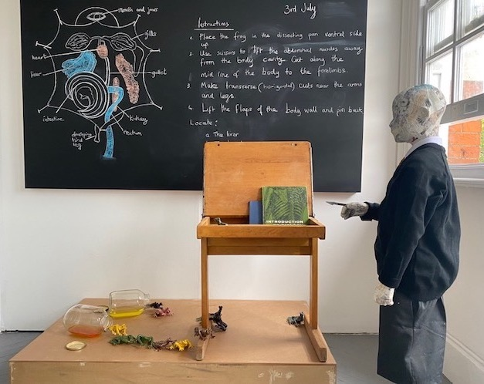

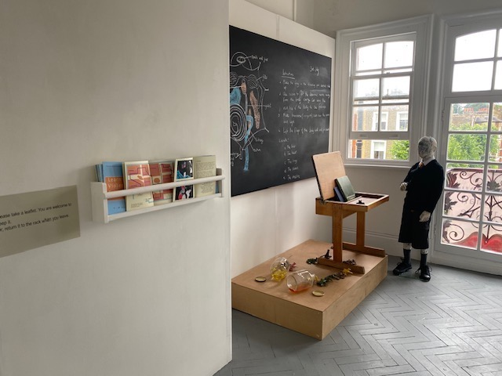

2. Installation – ‘site specific’ and non-site specific.
Installation art instigates dialogue by shifting the focus from what art visually represents to what it communicates. Installation allows the viewer to experience the work in an intimate and active way. Because of this it is useful for referencing cultural contexts and social concerns (Lopez, 2017).
My observations indicates that Installation art has the capacity to promote empathy, raise awareness, engagement, and challenge (Askew 2023). I propose exploring how this capacity can be extended to fully use the experiential aspects of installation for this purpose, as well as how fictioning (which assumes performative elements) can advance these aims.
As mentioned above, the first gallery within the Museum of Human Violence explored discourses of violence embedded in schooling. The second gallery explored ‘Violent Food Systems’ from the perspective of 2062:
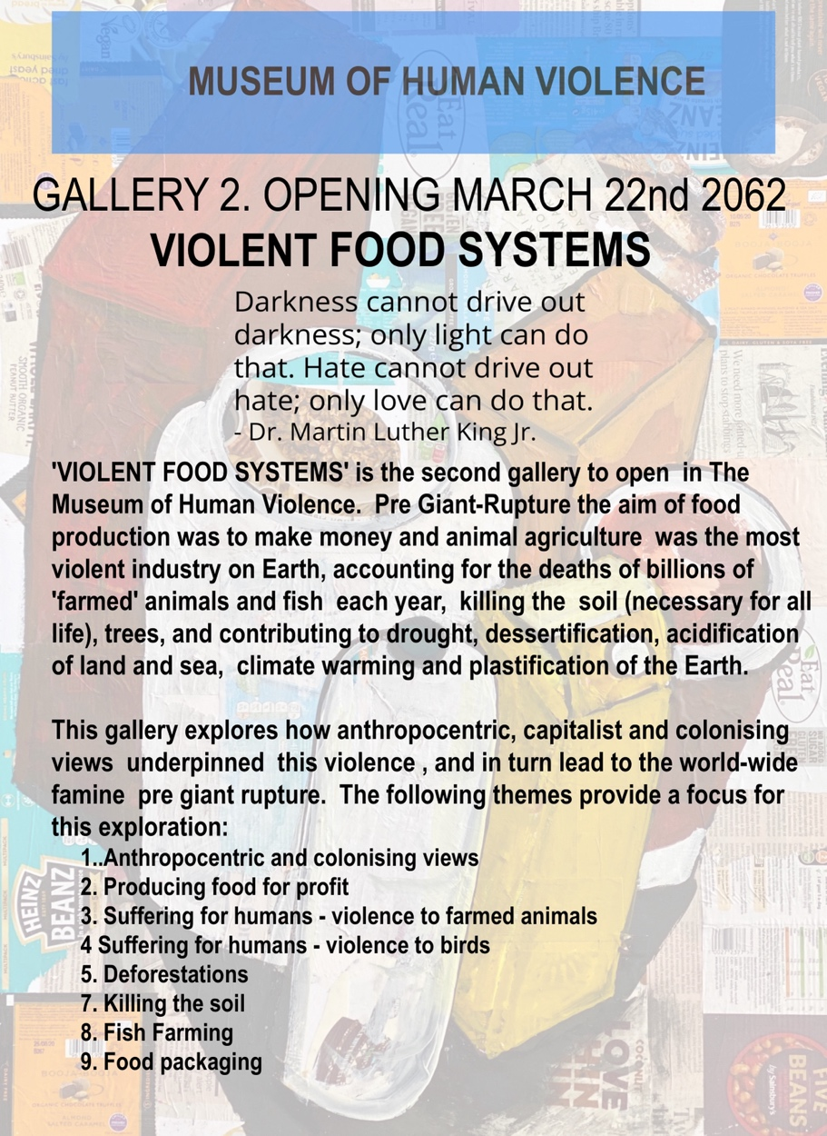

The photograph below shows part of this installation; specifically exploring ‘Violence to Farmed Animals’ and being taught ‘not to look’.
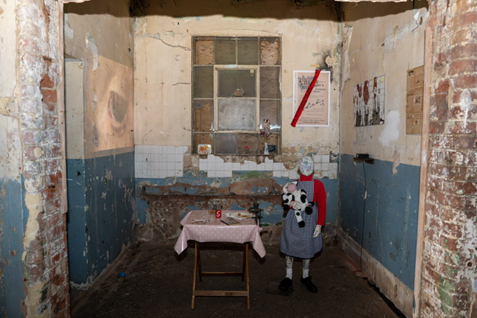
I have made a start on research into biocapitalism by analysing different aspects, simplified in booklet form, and a poster for the new gallery.
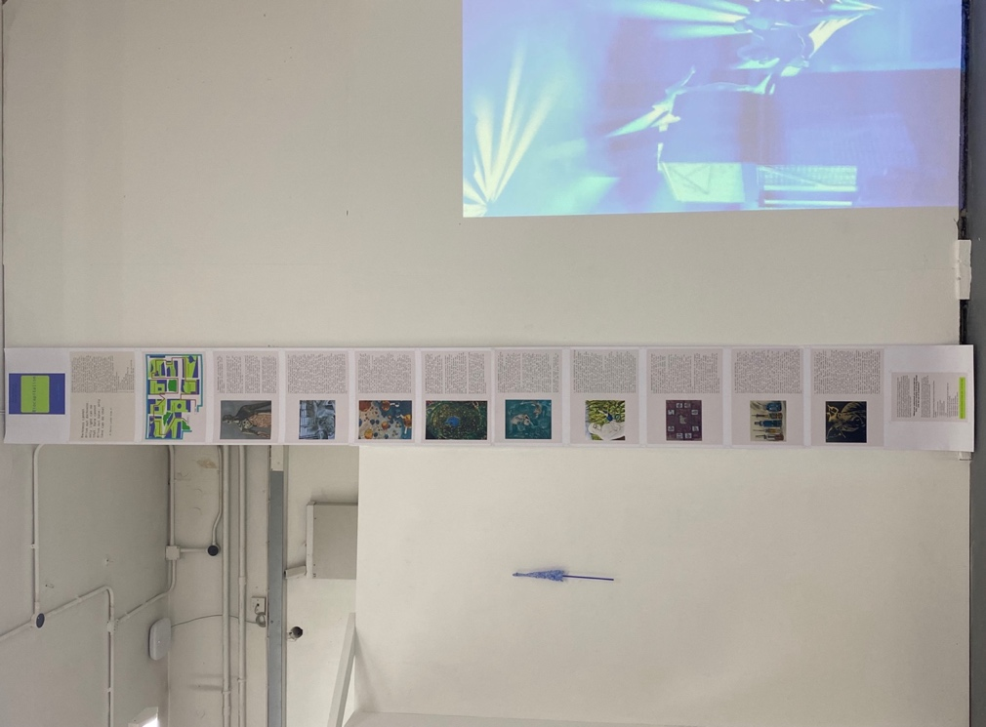
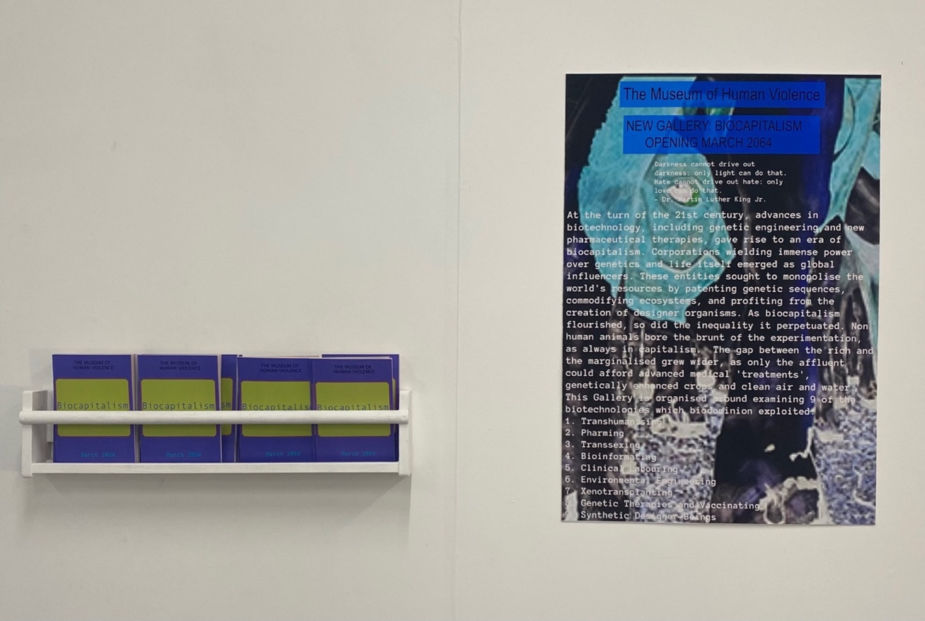

Fictioning includes performative elements in that it calls for both the maker, and the visitor, to imagine themselves in a future role. I have begun to experiment with performances focused on xenotransplantation: at Camberwell College of Art and at AMP Gallery. The participant is asked to imagine themselves in 2063 as an advisor to the planning committee for the new gallery in (because they have personal experience).

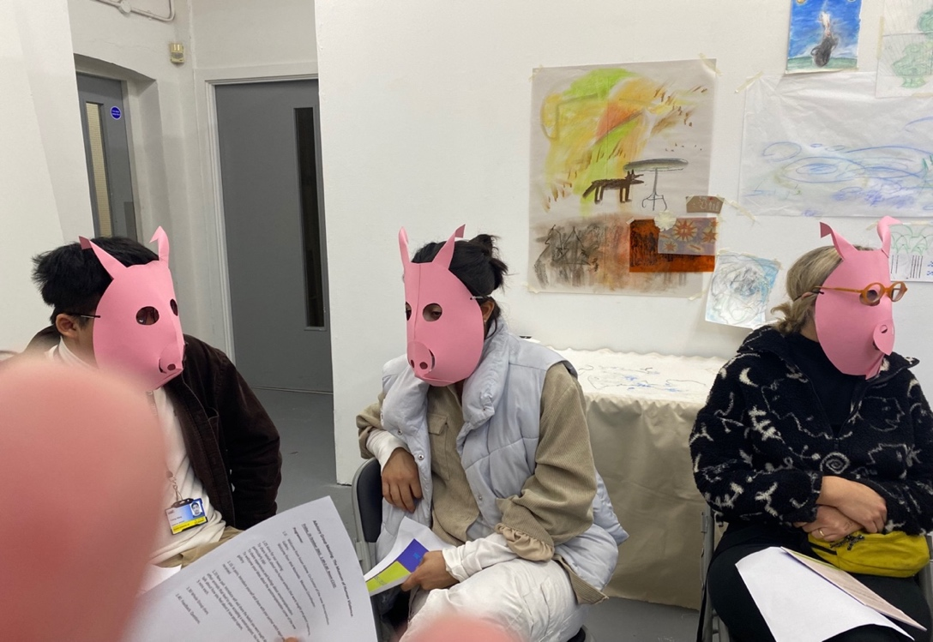

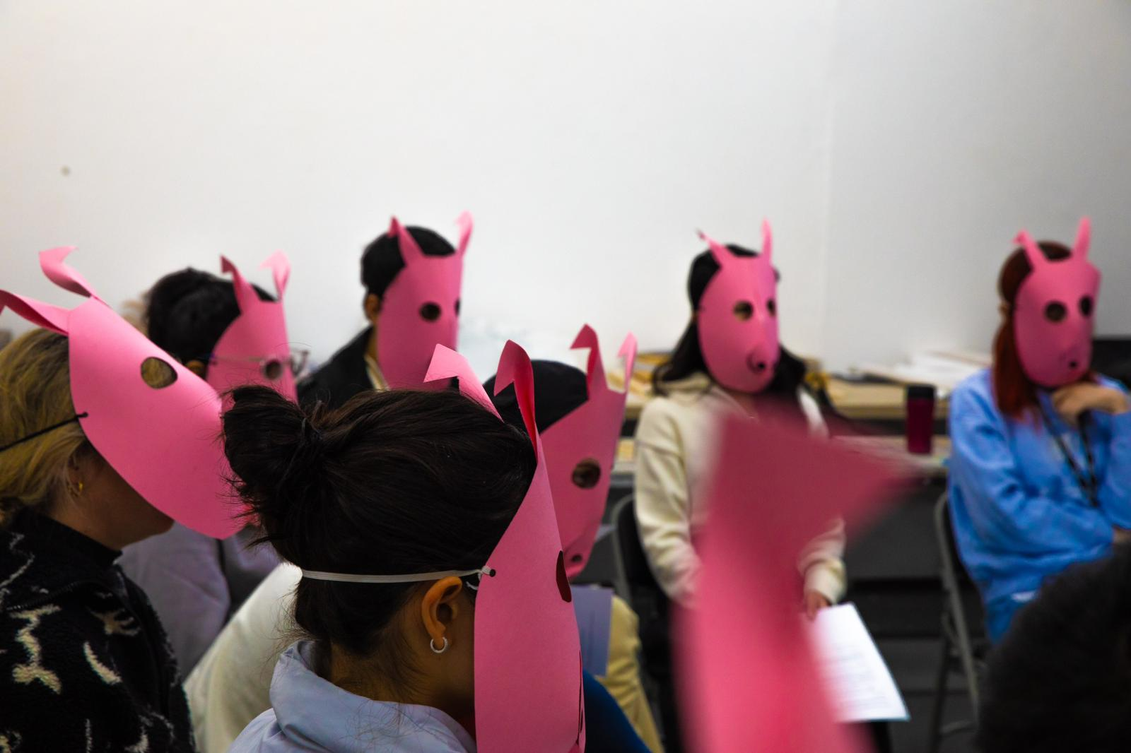

Theory
I draw on post-humanism (Haraway, 1988, 2016; Braidotti, 2021), particularly its critique of the notion that humans are superior to other life forms, all of which exist for our use; Critical Animal Studies (Best et al, 2007; Nocella, 2023) which has an intersectional approach to speciesism, highlighting the role of capitalism and commodification in injustice; and writing on biotechnologies and biopower (Foucault, 2008; Rajan, 2012; Askew, 2023b). In April 2024 I plan to attend a conference on Animal biotechnologies.
The most important question regarding biotechnologies connects to animal ethics. Related questions link to biopolitics and governance/control of both human and nonhumans; as well as exploration of the human-animal binary that makes xenotransplantation thinkable.
Foucault’s (2008) analyses of biopower offers useful insights and a critical perspective on emerging biocapitalism. Biopower refers to the explosion of techniques through which the modern nation state subjugates bodies and controls populations beginning in the late eighteenth century. (Helmreich (2008) suggests that Foucault’s notion of ‘biopower’ should be extended to include the governance not only of individuals and populations but control at the level of cells, molecules, genomes, and genes. And Woolfe (2012) makes a case for extending Foucault’s biopolitical analysis to include the lives of nonhuman animals and for it being a productive starting point for critically investigating the political conditions of our fellow living beings.
Among Foucault’s insights was the critical link he observed in liberalism between the governance of the self and government of the state. Foucault contends that politics were inseparable in its modern forms both from biology – biopower and the government of the living – and truth and subjectivity (Peters & Besley, 2008). The argument is that the growing biotech sector exists at a crucial nexus between government, power, and ethics and that biopolitical strategies are leading to new “states of domination.” (Peters and Venkatesen, 2010).
Some writers suggest that these new states of domination will always be partial and point to the fact that nonhuman as well as humans are agential, producing unexpected twists to our assumptions about how relations might unfold; attempts at control have unforeseen consequences that thwart ultimate human control over other animals, or other one another (Tovey 2003:4).
It is even suggested that biotechnologies have the potential to challenge the human-nonhuman binary and blur legal boundaries between the human and nonhuman (Knoppers and Greely, 2019). Dualism is a Western, historical method of constructing difference and stabilizing identity in terms of the logic of hierarchy (Plumwood, 1992:12) and conferring power in all modes of political struggle. Different dualisms form an ‘interlocking structure’ (Plumwood, 1993, p43) that reinforces a notion of human exceptionalism from ‘nature’ or ‘animal’. Other dualisms reinforce this principal binary: mind, and body, male and female, social and biological, reason and emotion. Dualisms are relational: externally they reinforce shared sets of ontological and normative assumptions between each other; internally they ascribe sharply demarcated essences (Twine, 2010).
Derrida suggested that a challenge to the human-animal dualism would challenge the very basis of modernity:
The tradition of differentiation that Derrida tracks … is animated by an ontological and linguistic violence that reduces what he calls “the heterogeneous multiplicity of the living” to a singular Other: the animal. Such efforts to demarcate the human have been central to a range of historical atrocities, from the legal, medical, political, and economic efforts to differentiate species that characterized slavery and colonialism to contemporary manifestations of racial and species hierarchy in industrial slaughterhouses in the rural US. To disrupt such forms of human-animal dichotomy is to challenge some of the fundamental cultural logics of modernity and empire, which render other beings killable, or at least exploitable, without the need for ethical reflection (Dawson, 10: 2015).
Dawson (2015) also argues that we need to return to Marx’s foundational question: ‘who benefits, when species meet?’ While it may be true that contemporary genomics is kindling new forms of co-production, which in turn demand new forms of recognition and empathy, Dawson writes that we need to see such changes in relation to the history of capital’s appropriation of bios.
I end with the reminder by Dawson (2015) that we should not, ‘lose sight of the iron laws of today’s biocapitalist economy and the global inequalities that it helps to cement in our efforts to survey and trouble fixed taxonomies of plant/animal/human.’

Objectives in year one:
- Make and show, iterations of the Biocapitalism gallery, using fictioning with installation/and/or performance to challenge, the implications of xenotransplantation for discourses relating to the human-nonhuman binary, particularly notions of human exceptionalism, and who is allowed to live/who to die.
- Explore the role of biotechnologies in governance and control, making visible the underpinning motive of profiting from life.
- Resolve problems identified in work as part of the MA Fine Art, 2023 and subsequent shows. These include gaining a clear picture of the fictional world of 2063/4; clarifying what happened at the ‘Giant Rupture’ (a fictional crisis around 2035); and resolving the issue of Authorship.
- I will keep ethical considerations at the forefront of all the work I make, including:
- Avoiding, where possible, the human gaze on other animals,
- Exploring the ethics of xenotransplantation.
- Examining my ethical responsibility to visitors.
For more images on ‘The Museum of Human Violence’ please see:
https://susanaskew.uk/unit-three-resolved-work
For critical reflection on this work see:
file:///Users/susanaskew/Downloads/book-4a-1-2.pdf

References
Arribas-Ayllon, Michael; Walkerdine, Valerie (2008). Foucauldian Discourse Analysis. London: Sage.
Askew, S. (2023) Installation and Fictioning for engagement, social justice, and change, in Reflections. Issue 2: Making conversations. https://mafaresearch.myblog.arts.ac.uk/2023/11/14/installation-and-fictioning-for-engagement-social-justice-and-change-%EF%BF%BC/
Askew, 2023b. Biocapitalism. https://susanaskew.uk/biocapitalism/
Best, S., Kahn, R., Nocella II, A and Gigliotti, C. (2007). Introducing Critical Animal Studies. in Critical Animal Studies, Vol 5, 1.
Peters & Besley, 2008
Braidotti, R. (2021) Posthuman Feminism. Cambridge: Polity Books.
Burrows, D. and O’Sullivan, S. (2019). Fictioning. Edinburgh University Press.

Cooper, Melinda. 2008. Life as surplus: Biotechnology and capitalism in the neoliberal era. Seattle, WA: University of Washington Press

Colombino, Annalisa and Giaccaria, Paola, (2016) Dead liveness/living deadness: Thresholds of non-human life and death in biocapitalism. Society and Space, Volume 34, Issue 6. Sage Journals.
Dawson, A. (2015). Biocapitalism and Culture. paper presented at the Environments and Societies colloquium on March 4. Available here: http://environmentsandsocieties.ucdavis.edu/files/2015/02/Dawson_Biocapitalism-Culture.pdf&nbsp;
Jacques Derrida, The Animal That Therefore I Am (New York: Fordham University Press, 2008

Demos, T. J. (2016) Decolonising Nature.: Contemporary Art and the Politics of Ecology. Berlin: Sternberg Press.

Demos, T. J. (2023) Radical Futurism: Ecologies of Collapse. Berlin: Sternberg Press.
Foucault, M. (2008) The Birth of Biopolitics. Lectures at the College de France, 1978-1979. Trans. Graham Burchell. New York: Palgrave Mac- millan

Fox, M. (2005) Reconfiguring the Animal/Human Boundary: The Impact of Xeno Technologies.Liverpool Law Rev 26, 149–167. https://doi.org/10.1007/s10991-005-4841-8
Haraway, D. (1988). Situated Knowledges: The Science Question in Feminism and the Privilege of Partial Perspective. in Feminist Studies, Vol 14, 3. pages 575-599.
Haraway, D. (2016) Staying with the Trouble: Making Kin in the Chthulucene. Duke University Press.
Helmreich, S. (2008), “Species of Biocapital,” Science as Culture 17(4): 463–478
Holland, A. and Johnson, A. (1998) Animal Biotechnology and Ethics. London: Chapman and Hall.
Kester, G. H. (2010). Conversation Pieces: Community and Communication in Modern Art. USA: University of California Press.
Knoppers, B. and Greely, H. (2019) Biotechnologies nibbling at the legal “human.” Science. Vol. 366. No 6472. Pp 1455-1457.
Lopez, 2017. "Installation Art Movement Overview and Analysis". TheArtStory.org Edited and revised, with Summary and Accomplishments added by Kimberly Nichols Available from: https://www.theartstory.org/movement/installation-art/ [Accessed 02 May 2023]
Nocella, A. J. and White, R. J. (2023) (eds). Critical Animal Studies and Activism. International perspectives on total liberation and intersectionality. New York: Peter Lang.
Olufemi, L. (2021). Experiments in Imagining Otherwise, London: Hajar Press.
Peters. Michael, A. and Venkatesen, P. (2010). Biocapitalism and the politics of life. Geopolitics, History, and International Relations, Vol. 2, No. 2 (2010), pp. 100- 122
Plumwood, V. (1993). Dualism: the logic of colonisation. Chapter Two In Val Plumwood, Feminism and the Mastery of Nature. London: Routledge.
Rajan, K. S. (2012) (ed.), Lively Capital. Durham, NC: Duke University PressMarkets (Durham, NC: Duke University Press, 2012), 2.
Simoniti, V. (2021) Art As Political discourse. British Journal of Aesthetics. Vol 61. Issue 4, October. pp 559-574.
Tovey, H. (2003). Theorising Nature and Society in Sociology: The Invisibility of Animals. Sociologia Ruralis, 43(3), pp.196-215.
Twine, R. (2010) Animals as Biotechnology: Ethics, sustainability, and critical animal studies. Washington DC: Earthscan

Weinbaum, A. E. (2022). The slave episteme in biocapitalism. Catalyst: feminism, theory, thechnoscience. Vol 8. No 1.

Wolfe, C. (2012). Humans and Other Animals in a Biopolitical Frame. University of Chicago Press.
nationallinkcoalition.org (the links between violence toward other animals and inter-human violence)

All images of work by Susan Askew for ‘The Museum of Human Violence, 2063)

